Midterm Exam Lab: Gray Code Counter

Author: Seth Ricks
Date: 10/31/2025
Class: ECEN 340

Objective:
Write and implement the Verilog code for the Gray-code counter you designed in the written portion of the exam (the sequence is 111, 011, 010, 110, 100, 000, 001, 101).
Overview:
The goal of this lab was to create a gray-code counter with the sequence above, using four modules. The result used this counter to display to three LEDs onboard, with a button to restart the sequence. I also included three more unique sequences, each for extra credit.
- Module 1, “gray_counter”
- Module 2, "clock_gen”
- Module 3, gray_counter_top”
- Module 4, "gray_counter_top_tb”
- Extra credit part 1: second gray counter sequence
- Extra credit part 2: third gray counter sequence
- Extra credit part 3: fourth gray counter sequence

Results/Report:
Part 1 – gray_counter
The gray counter module keeps track of the next state for each bit in the counter. I came up with these equations using a truth table converted to a Karnaugh map. An image of the gray_counter module can be seen in Figure 1.
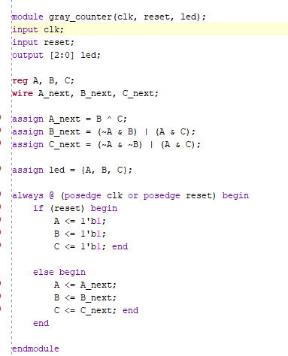
Figure 1

Part 2 – clock_gen
The next thing that is needed is the clock_gen module. This module is responsible for how fast the bits are changing, as the clk_out will later be passed into the gray_counter module to control how fast the edges happen. There are two assign statements in this module for clk_out, one of them is commented out. The purpose in having two of them is to have one for simulation, and one for uploading to the FPGA board. The third bit of the counter is used for the simulation, and the 25th bit is used for the physical board. An image of the clock_gen module can be seen in Figure 2.
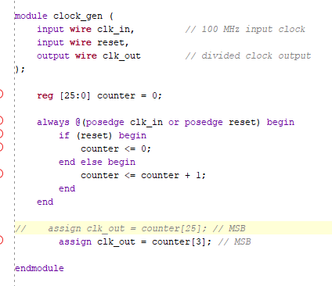
Figure 2

Part 3 – gray_counter_top
Now we need a module to put all the past ones together. Namely, the clk_gen needs to pass its output into the gray_counter, but also both modules need variables from the constraint file. To do this, we make a gray_counter_top module. An image of this module can be seen in Figure 3.
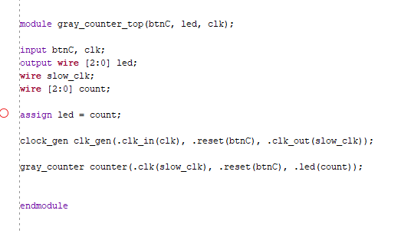
Figure 3

Part 4 – gray_counter_top_tb
It is faster to test in simulation than to upload the code to the board. So we need to make a testbench, called gray_counter_top_tb. The test module is gray_counter_top, which instantiates this module and passes in wires and registers. We then toggle the clock every 5 nanoseconds, and then simulate for 1000 nanoseconds. An image of the testbench file can be seen in Figure 4. The results of the simulation can be seen in Figure 5. You can see that sequence is 7, 3, 2, 6, 4, 0, 1, 5 as desired.
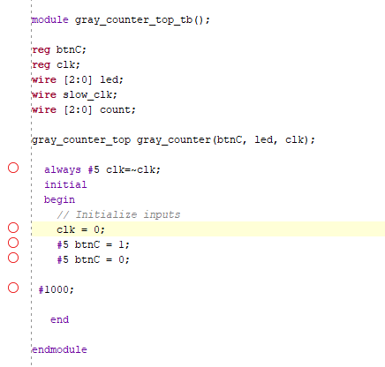
Figure 4

Figure 5

Parts 5-7 – more gray-code counter sequences
For extra credit, I decided to create 3 more gray-code counters. These sequences are unique, and can be seen in Figure 6. The second sequence is completely unique, and the third and fourth sequences are mirrors of the first two.
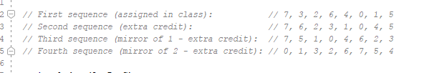
Figure 6
To switch between all four sequences, I made use of the switches on the board. I configured the first two switches, sw[2:0], to control the sequences in the order they are shown above. To do this, I modified my gray_counter module to use a case statement inside of an always block instead of an assign statement. I derived this equations in the same way that I did above, using logic tables. This logic can be seen in Figure 7.
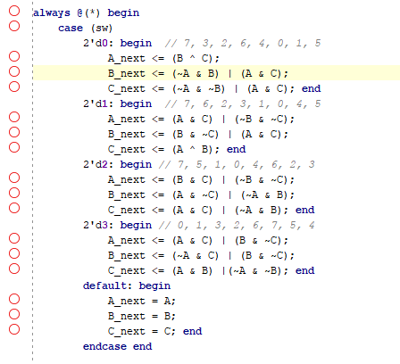
Figure 7

I needed to modify my test bench to accommodate these switches. So, I set each switch to the desired order, from decimal 0 to decimal 3. After setting each value I ran the simulation for 1500 ns, in attempt to see the entire counting sequence each time. An snippet of the testbench code can be seen in Figure 8.

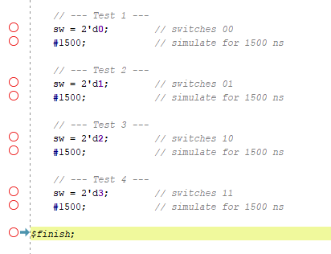
Figure 8

The results of this simulation can be seen in Figure 9 below. As desired, when the switches are ’00,’, the sequence is the same as before. When the switches are ‘01’, the sequence is ‘7, 6, 2, 3, 1, 0, 4, 5’. When the switches are ’10,’ the sequence is ‘7, 5, 1, 0, 4, 6, 2, 3’. When the switches are ‘11’, the sequence is ‘7, 5, 4, 0, 1, 3, 2, 6’. They might not be starting with 7 in the simulation, because of where each sequence is starting when the switches change. But this is intentional, and the sequence can be reset to ‘7’ by pushing button “c”.
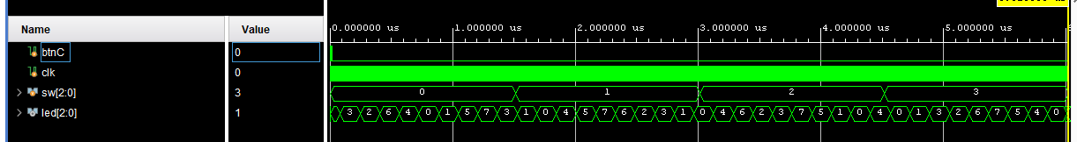
Figure 9

I also generated a schematic of these counters, which can be seen in Figure 10 below.
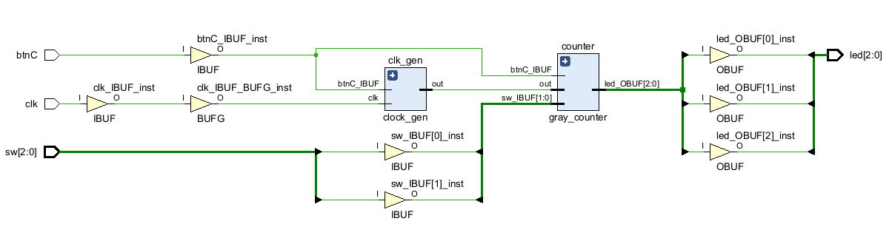
Figure 10
Finally, it was time to test it on the board! It worked as intended, which is hard to prove without including a video of the sequences. But describing the functionality, the two switches on the rightmost side of the board control which sequence the counter loops through. The sequence changes to the next state when the switches change, instead of starting at a certain point. For example, if the switches are ‘00’, and we see ‘7… 3… 2…’ and we change the switches to ‘01’ while the lights are on 2, the next numbers we will see will be ‘3… 1… 0…’ because the second sequence has 2 go to 3. The button ‘c’, or the center button, resets the sequence no matter what sequence you are in to ‘7,’ or all three leds lit.

Conclusion:
The functionality of my design was exactly as intended. It had four gray codes, and was able to switch between them very well. One way that I think this could improve would be to use a lookup table for these counters instead of logic equations. This would make it easier to add even more sequences if desired, instead of having to figure out the Boolean expressions. Overall, I think this lab was a success, and I had a lot of fun with it!

